Advocacy support  - Llais support centre can be contacted on 02920 235 558  - Meic is the helpline service for children and young people up to the age of 25 in Wales 0808 80 23456  - Age Cymru may have advocates in the area. Visit their website or call 0300 303 44 98  Further action  If you are dissatisfied with the outcome of your complaint from either NHS Wales or this practice, then you can escalate your complaint to:  Public Services Ombudsman for Wales  1 Ffordd yr Hen Gae  Pencoed  CF35 5LJ  Tel 0300 790 0203 or email ask@ombudsman-wales.org.uk | Pontprennau Medical Centre  33 Kenmare Mews, Pontprennau, Cardiff, CF23 8RJ  Tel: 01291 739999 Email: reception.pontprennau@wales.nhs.uk Copy of Complaints policy available on our website www.pontprennaumc.wales.nhs.uk |  | The Complaints Process  Pontprennau Medical Centre  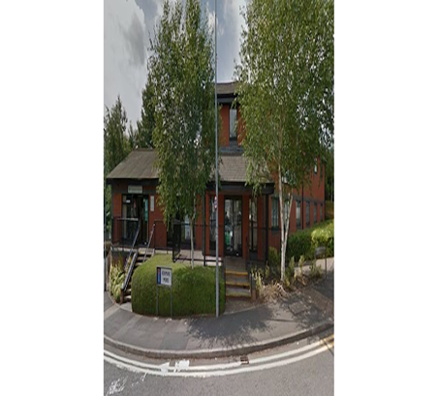

We will aim to investigate and provide you with the findings within 30 working days upon receipt and will provide regular updates regarding the investigation of your complaint.

How to make a complaint
A complaint can be made verbally or in writing.
A complaints form is available from reception. Additionally, you can complain via email to reception.pontprennau@wales.nhs.uk

If a data complaint, you may also complain to the Information Commissioner’s Office should you be dissatisfied with the initial response. The ICO provides guidance for complaining about a data breach.

Investigating complaints
The Complaints Manager will investigate all complaints effectively and in conjunction with extant legislation and guidance.
Confidentiality
The Complaints Manager will ensure that all complaints are investigated with the utmost confidentiality and that any documents are held separately from the patient’s healthcare record.
Third party complaints
Pontprennau Medical Centre allows a third party to make a complaint on behalf of a patient. The patient must provide consent for them to do so. A third-party patient complaint form is available from reception.
Final response
Pontprennau Medical Centre] will issue a final formal response to all complainants which will provide full details and the outcome of the complaint
Talk to us
Every patient has the right to make a complaint about the treatment or care they have received at Pontprennau Medical Centre.

We understand that we may not always get everything right and, by telling us about the problem you have encountered, we will be able to improve our services and patient experience.

Who to talk to
Most complaints can be resolved at a local level. Please speak to a member of staff if you have a complaint; our staff are trained to handle complaints. Alternatively, you can put your complaint in writing.

If for any reason you do not want to speak to a member of our staff, then you can request that the Local Health Board investigates your complaint. They will contact us on your behalf:

Cardiff and Vale Health Board
Tel: 02921 836318
Email: concerns@wales.nhs.uk

Write to: Chief Executive,
Cardiff and Vale University Health Board, Maes y Coed Road,
Cardiff,
CF14 4HH

A complaint can be made verbally or in writing. A complaints form is available from reception. Additionally, you can complain via email to reception.pontprennau@wales.nhs.uk

Time frames for complaints

The time constraint on bringing a complaint is 12 months from the occurrence giving rise to the complaint, or 12 months from the time you become aware of the matter about which you wish to complain.

The Complaints Manager will acknowledge any complaints within two business days.

